**Azure data bricks Assessment 1 :** - Abhiram Basa

Today we started with introduction to Azure Data Bricks and allotted the Azure Data Bricks account.

**Data Bricks:**

* It is developed by Apache Spark.
* It is an web based platform for working with the Apache Spark.
* It provides automated cluster management.

**Azure Data bricks:**

* It is an cloud service platform to work with Apache Spark and data bricks.
* It is developed by Microsoft.

**Account Activation for Azure Data Bricks:**

* First we need to login to Make my labs.
* Click on connect
* It will give credentials for azure account and using those you can login.

**Make My Labs dashboard:**

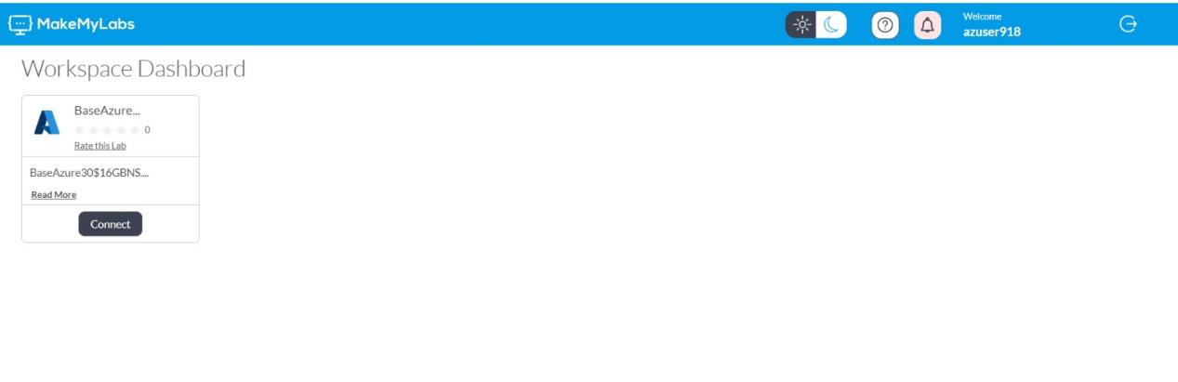

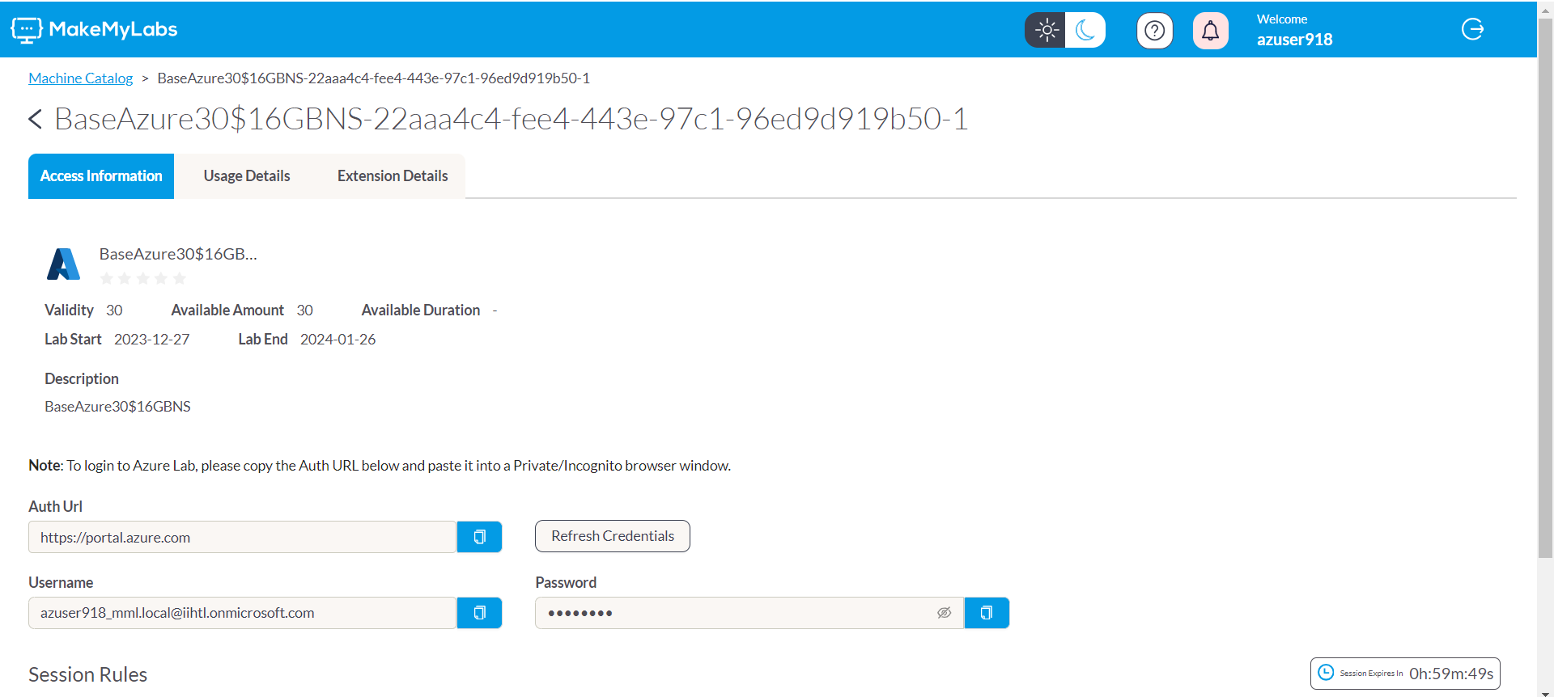

**Azure Dashboard:**

* In this we can practice Azure data bricks, etc.
* We can create resources.

